CIS250 *Quiz 4* - Excel Basics (“Take Home” Assignment)

***Read Office Excel Tutorial 3 and complete the related Review and Project in SAM 2013 before working on this assessment. It will be included with the overall Quizzes tally and will help you prepare for the upcoming Test. You may work on this assignment with other CIS250 students.***

Name: Smith, Noah |

CIS250: -06 |

Date: Wednesday, February 07, 2018 |

Hours: .65 |

The purpose of this second “take home” assignment is to assess your knowledge, understanding, and application of:

* More advanced calculations and mathematical formulas within the context of a spreadsheet
* Fundamental Excel® skills and tools in solving common problems in the world around you
* Simple Excel® functions: AVERAGE, COUNT, COUNTA, IF, MAX, MEDIAN, MIN, MODE, ROUND, SUM

Students should not use MS Excel® to solve any of the following problems. Instead, your responses should be entered directly into the respective answer fields provided on the next page. A couple of Web references are provided to assist with more complex formulas. You are also encouraged to review Excel Tutorial 3 in the *New Perspectives (First Course)* textbook along with the respective reference information in the two supplemental textbooks noted in *Course Syllabus*.

First, update the identification information in the shaded area above. Be sure to include your first and last name as well as the specific CIS250 section number that you are in. For the date, press the F1 key to request **Word Help**, then search for the term “date” in order to find out how to insert today’s date in the remaining shaded area above, using the format:

“dddd, MMMM dd, yyyy”

Next, be sure to update the information in the page header by entering it in the upper left corner of page 2 only.

Students can use virtually any more recent version of Microsoft® Word to record answers to the problems on the following pages, although you are *strongly encouraged* to use Microsoft® Word 2016. If you do not have access to a PC with this application software, Microsoft® Office 2016 is available on *many* UofL computers that are installed for student use in the College of Business (CoB), Davidson Hall, REACH/CRC (over in Ekstrom Library), and Miller Information Technology Center (MITC). Check the two related items in the ***Getting Started*** folder of Blackboard for additional information for accessing MS Office 2016.

Be sure to check your answers against the solution set provided in Blackboard in a Portable Document Format (PDF). It is not necessary to include more than one answer for each problem, although you are certainly encouraged to consider alternative solutions that will also work. You should use Excel to validate a specific answer only if absolutely necessary.

Please feel free to email your professor should you have any questions or issues concerning this particular assignment. Students are encouraged to use tutoring services offered at no charge through REACH/CRC. Click on the following URL for additional details:

[***http://www.reach.louisville.edu/tutoring/computer/***](http://www.reach.louisville.edu/tutoring/computer/)

Once you have finished responding to all of the questions below, enter the total elapsed time it took you to complete this assignment in the respective text box near the top of this page.

**Part 1:** Solve each of the following problems using basic calculations created in the form of Excel® formulas.

1. Reference the diagram of a fish shown below. The formula to calculate the approximate weight for most species of freshwater fish is:  
     
    **WEIGHT = LENGTH * GIRTH ^ 2 / SHAPE FACTOR**  
   Assume that a fisherman caught a largemouth bass that measured in at 22 1/2 inches long, with a girth of 19 inches. The shape factor for a largemouth bass has been set by the fishing industry at 1050. Write a formula to determine the estimated weight of this fish.

=22.5*19^2/1050 |

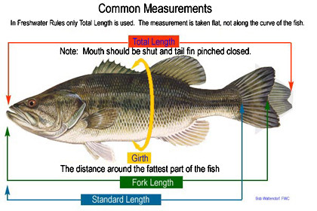

1. The law defines the regulated community as those animal production facilities that are high density *and* have more than 2,000 pounds (one ton) of live animal weight per acre on land which is deemed suitable for manure application. These operations are defined as Concentrated Animal Operations (CAOs) under the law. The law includes all livestock, whether they are used for production or recreation. Assume that a stable boards 12 horses (each weighs an average of 1,000 pounds) on 5 acres of land. Write a formula that can be used to determine the total live animal weight *per acre* for this regulated farm operation.

=(12*1000)/5 |

1. A "hand" is a unique unit of measure in the equine industry equal to **4 inches** - it is used to measure the height of a horse from the ground to the highest point of the withers (the last hair of the mane on most equines). The number of whole hands is properly followed by a period (which should not be confused with a decimal point), then any remaining height less than a hand specified in inches after the period. Given this information, write a formula that will properly determine how tall a given horse is in *feet* if it measures **19.2 ½ hands**.

=(19.25*4)/12 |

1. Reference the diagram of a horse shown below. Assume that a stable does not have a weighing scale, but needs to estimate the weight of a horse for the purpose of determining feed and medication. The horse has a girth (defined as the circumference around the body measured at the heart) of 77 inches. The body length for this same horse measures in at 65 inches. Write a formula that will determine the estimated weight for this horse.

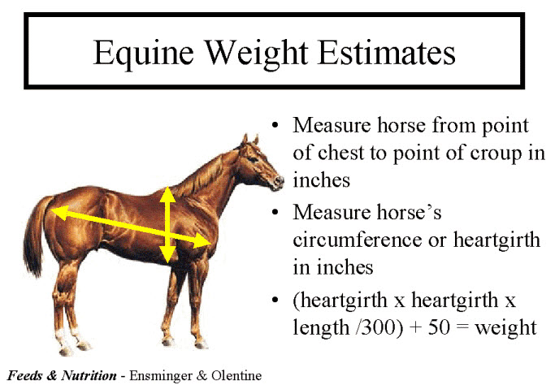

=(77*77*65/300)+50 |

1. Horses of all ages require adequate amounts of feed for growth, maintenance, reproduction and work, with reproduction and growth being the most critical factors. For hard feeds, there are feed charts on the back of every bag, and you have to multiply the stated factor provided in the directions to calculate the nutritional value. It will usually appear something like:

***0.4 lbs of feed for every 100 lbs of body weight per day***

Using the weight of the horse in the previous example (which was about 1,335 pounds), write a formula that will determine the amount of hard feed that such a large horse requires on average per month. You can assume there are thirty days in a typical month for calculation purposes.

=((1335/100)*.4)*30 |

1. Horses produce large amounts of manure. In fact, if the manure produced from one horse were allowed to pile up in a 12-ft x 12ft box stall for one year, it would accumulate to a height of over six feet. Manure includes both solid and liquid portions of waste - 60% solids and 40% urine. Every day, a horse produces about 0.5 ounces of feces and 0.3 fluid ounces of urine per pound of body weight. If a 1,000-pound horse produces about 31 pounds of feces and 2.4 gallons of urine (which weighs 8.33 pounds per gallon) daily, write a formula to determine the weight of manure that this horse will likely produce in an entire year?

=((2.4*8.33)+31)*365 |

1. A **ton** is a unit of mass in different measurement systems and is often mistaken with each other. The short ton (also known as net ton) equals to 2,000 pounds and used in North America (United States and Canada), while the long ton (also known as weight or gross ton) is used in the Imperial System (United Kingdom and other countries around the world). It is defined as 2,240 pounds. If a 1,000-pound horse domiciled in the U.S. produces about 9.3 tons of manure each year, create a formula to determine how many kilograms of waste it produces each day. Remember that you must apply a conversion factor of one pound => 0.4536 kg.

=(9.3*2000)*.4536 |

**Part 2:** Judson Ford Realty uses an Excel® spreadsheet to keep track of October Sales. Study the summary data shown in the spreadsheet image directly below and then answer the following questions based on the information provided.

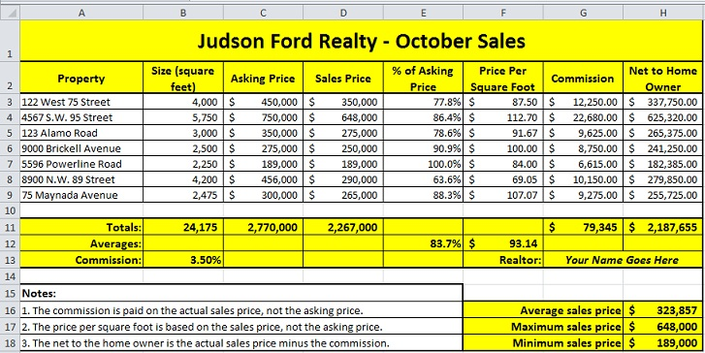

1. Compute the total commission for all homes sold by writing the formula that belongs in cell G11.

=SUM(G3:G9) |

1. Using a single function, what formula would you use in cell H16 to obtain the correct result?

=AVERAGE(D3:D9) |

1. Without using the AVERAGE function, what formula would you use in cell H16 to render the same result?

=(D3+D4+D5+D6+D7+D8+D9)/7 |

1. What formula would you use in cell H17 to obtain the correct result?

=MAX(D3:D9) |

1. What formula would you use in cell H18 to obtain the correct result?

=MIN(D3:D9) |

1. What formula would you use to find the most frequently occurring Asking Price for these homes?

=MODE(C3:C9) |

**Part 3:** Solve each of the following problems, then answer both of the questions at the bottom of this page.

1. What is the simplest formula (hint - use a single function) would you use to calculate the arithmetic mean of the following data set: 11, 22, 33, 44, 55?

=AVERAGE(11,22,33,44,55) |

1. Assume that cell B1 contained the formula you provided to correctly answer (a) above. What formula would allow you to round that result to the *nearest whole number*?

=ROUND(B1,1) |

1. What formula would you use to determine the *most common* value of the data set: 7, 9, 3, 5, 7, 1?

=MODE(7,9,3,5,7,1) |

1. Assume for a moment that last year’s labor rate for a building inspector hired by the city was $35 per hour. For this year, the union negotiated a contract with a $39.95 per hour rate on behalf of all of the inspectors. What algebraic expression could you use to determine the percent increase in labor costs? ***Note****: Assume that the cell is set for a General format, not percent.*

=1-(35/40) |

1. Assume the calculation to solve the problem immediately above (e) is entered correctly into cell C1. What formula can be used to round that specific cell to two significant digits *after* the decimal point?

=ROUND(C1,2) |

1. Assume that a billboard on an interstate highway rents for $0.35 (35 cents) per hour and rents by the month. What formula should be used to determine the bill for the entire month of September?

=.35*24*30 |

1. Review the accompanying worksheet image. What is the result of evaluating the following formula?

**=SUM(MAX(B4:E4),MIN(B5:E5),MEDIAN(B6:E8))** 32.5f |

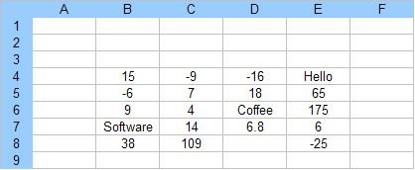

1. *True* or *False?* When using the *Increase Decimal* button on the Excel ribbon, the precise value that was originally stored in the active cell (and also shown in the *Formula Bar*) is also modified.

false |

**Part 4:** Examine the accompanying worksheet image which shows the major continents on earth along with their respective areas in millions of square miles. Answer each of the six questions below.

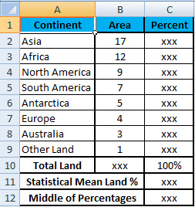

1. Which Excel feature (a toolbar button, not function) should be used in cell B10 to determine the total land mass for all continents?

autosum |

1. Assuming a cell format of General is being used, what formula should be entered in cell C2 to determine the precise percentage of the total land mass that Asia occupies?

=B2/B10 |

1. What single function should be entered in cell C11 to determine the statistical mean for the column containing percentages of the total land area that each of the continents cover?

=AVERAGE(C2:C9) |

1. Assume that the calculation to solve the problem immediately above (c) is entered correctly into cell C11. What formula can be used to round that specific cell to the nearest *whole number* (or *integer*)?

=ROUND(C11,0) |

1. What formula should be entered in cell C12 to determine the number in the middle of the given set of percentages for the total land area that each of the continents cover?

=MEDIAN(C2:C9) |

1. Under which group in the Excel Ribbon would you find the button that controls the predefined thick and thin lines that you can quickly add around cells for decorative effect as shown in the image above?

Font |

**Part 5:** Examine the accompanying worksheet image which shows the major oceans on earth along with their respective areas in millions of square miles. Answer each of the six questions below.

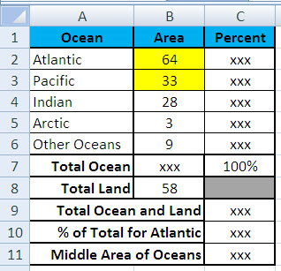

1. Without using the SUM function, what formula should be entered in cell B7 to determine the total area that all of the world’s oceans cover?

=B2+B3+B4+B5+B6 |

1. What simple formula should be used in cell C9 to compute the total square miles that all continents and oceans occupy on earth?

=B7+B8 |

1. What value results in cell C10 after entering a formula to determine the percentage of area on earth that is occupied by the Atlantic Ocean, to the nearest percent?

47% |

1. What formula should be placed in cell C11 to determine the middle area (in percent, not average) for the five oceans listed?

=MEDIAN(B2:B6) |

1. Assuming that a cell format of General is being used, what formula should be entered in cell C3 to determine the percentage of the total ocean that is occupied by the Pacific Ocean?

=B3/B7 |

1. Using an IF function, create an expression in cell C8 that will show the larger of “Land” or “Ocean” area.

=IF(B7>B8,Ocean,Land) |

|  |  |
| --- | --- |
|  | **Congratulations - you are nearly done with *Quiz 4*! Perform one final review of this**  **Microsoft® Word document and its accompanying instructions to ensure you have  successfully completed all steps. During the review process, be sure to note the actual  number of hours (elapsed clock time) that you spent on *Quiz 4* at the top of the first page  of this document in the designated box. Then save this Microsoft® Word file to your**  **PC hard drive or USB thumb drive and create a backup copy of it for future reference.** |

●●●

|  |  |
| --- | --- |
| MCj04348050000[1] | **Be sure to rename your Microsoft® Word document template file beginning with your first and middle initials concatenated with your full last name, followed by a dash, then the text "Quiz4-Solution" before the ".docx” file extension. For example, if you have a first name of “Bubba” and a middle name of “Joe” plus a last name of "Gump" then you would name your file "*BJGump-Quiz4-Solution.docx*" - once you have done this, you will need to convert your solution file to a PDF using the Microsoft® Office 2016 *File* option *Export*, then click on the *Create PDF/XPS* button.**  **If you are using a Mac, please see the respective instructions in *Step 14* of *Lab Assignment 1* for details about how to create a PDF. Finally, post your completed *Quiz 4* digital solution file into Blackboard under the respective *Submit Work Here* folder item for subsequent grading.** |
| ●●●  *Due dates and times for assignments are documented in the Assignment Due Dates worksheet and under* ***My Grades*** *in* ***Blackboard*** *or MyITLab, respectively. No solution file will be accepted for grading after the due date unless you have notified me in advance of an extenuating circumstance as described in the Course Syllabus.**Please feel free to contact me via email if you have any questions/issues regarding this specific assignment. If you have any comments about this assignment for me, you should make note of them in the blue comments area directly below and NOT in the* ***Submit Work Here*** *folder item while you are posting the solution file into Blackboard for grading.* | |

***Note:*** *The solution file for Quiz 4 must be submitted in Adobe PDF document format*

*for grading using the proper file name as noted in the 2nd paragraph of this page.*

*Students will be awarded up to 25 points for Quiz 4 if it appears to be fully complete and only 10 points if it is materially incomplete. Zero points will be awarded if you fail to submit a digital file for grading or if it is substantially incomplete. Points may be deducted for incorrect responses, so be sure to check the Solution PDF before submitting your responses*

Type any comments about this “take home” assignment

for the your professor (or grading assistant) here.